The Day of the Lord

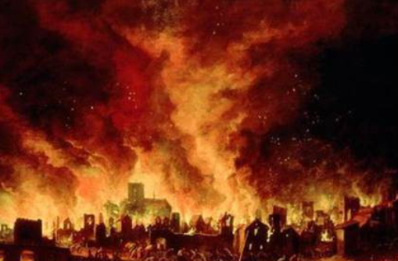

A study in Obadiah

Introduction
Obadiah was written after the fall of Jerusalem in 586 BC, when the city had been totally destroyed including the Israelites place of worship, the temple. The Israelites had been deported from there to Babylon. They were a defeated people with no place to worship their God.

Obadiah predicts doom for the people of Edom. This nation lived in a mountainous area just south of Israel and were descended from Esau, who was also called Edom. (Gen. 25:30) Hence Esau and Edom are used interchangeably in Obdiah. Esau was the brother of Jacob, who stole Esau’s birthright and blessing before later becoming Israel (Gen. 25-33). The Edomites and the Israelites were related, which meant Israel went around Edom when coming up to the land of Israel from Egypt, when Edom would not allow them to pass through (Numbers 20:14-21, going around rather than fighting their brothers).

Edom’s behaviour towards their brother-nation Israel was picked up by many of the prophets, who consistently predicted Edom’s doom (e.g. Is. 34, Jer. 49). Not only are the ideas similar but with Obadiah 1-6 and Jeremiah 49:7-22 contain so many identical phrases, that it suggests either they have a common source or that one was used in writing the other.

Obadiah – The Day of the Lord
Read Obadiah 1-21.
What stood out to you?

Focus on verses one to nine.
What message does God send? Who to? (v1)

What does God say will happen to Edom?

Why is Edom surprised by this?

Where does Edom's pride come from?

Why is pride so dangerous?

In what areas are you proud and secure? What are the dangers of your pride?

How bad are things going to get for Edom?

What will they lose?

Who will do this to them?

Focus on verses ten to fourteen.
Why is God's judgement against Edom so harsh?

What has Edom done to Judah?

How should Edom have reacted to the fall of Judah?

How should we react when we see brothers and sisters in trouble? Does it matter if they had it coming?

In 553 BC Edom was invaded and conquered by the Babylonians, their allies in destroying Jerusalem. The remaining Edomites continued to exist in the surrounding area for another century, but eventually became parts of other peoples. Edom lost its identity and no Edomites remained.

What does this event tell us about the sovereignty of God?

Why do you think that Israel was not one of the nations involved in bringing judgment on Edom?

Seeking revenge is something followers of God are not supposed to do. (see Romans 12:19-20, Deuteronomy 32:35, Proverbs 25:21-22). Do we ever seek revenge? How should we respond when others hurt us?

Focus on verses fifteen to twenty-one.
What does the day of the LORD bring?

Through the prophets in the Old Testament one of the pictures of judgment is nations drinking from the Lord’s cup of wrath (see Job 20:21, Isaiah 51:17, 51:22, Jeremiah 25:15, 25:17, 28, 49:12). This is often shortened to a cup that the nations drink from as here (see also Psalm 25:8, Ezra 23:31, 23:32, 23:33, Habakkuk 2:16). In verse sixteen it seems Obadiah is switching to addressing the Israelites directly (the you for the Israelites is plural, while you singular is used in addressing Edom), although this does not significantly change the message.

How does what will happen to all nations compare to what happened to Israel? Is it worse?

What are the good things that are prophesied for Israel?

Who will be in charge when the exiles return?

Why does “The Lord has spoken” (v18) suggest that the prophecy is certain to happen?

How would this prophecy encourage and comfort the Israelite community in exile?

Why were the Israelites still looking for the day of the Lord, after they returned from Babylon?

In v17 Obadiah says “on Mount Zion will be deliverance”. Mount Zion is the mount on which David built the citadel that became Jerusalem and so is used for Jerusalem. Has there been deliverance at Jerusalem? What does this mean for our lives?

Does this mean God’s kingdom is fully established?

Read Rev. 20:11-21:7
When will God's kingdom be fully established?

What events occur on that day?

What are the similarities between this prophecy and Obadiah?

After Christ’s death and resurrection, the people of God consist of those who put their identity in Christ. With the destruction of Edom, there are no longer any brothers of the people of God. Your identity is either as a member of the people of God when the day of the Lord is our hope, or you are a member of the other nations when the day brings judgment.

Do we look forward to the day of the Lord? Why?

How are we at following God when we go through difficult times? What encourages you?

How does the hope of Jesus' return affect our behaviour in these times?

Prayer Points:
- Thank God for the deliverance we have in Christ and that he will return.
- Ask God for the areas in our lives where we find it difficult to love others and represent him to them where we ought
- Pray for any who going through difficult times for encouragement and hope

Studies prepared by Andrew Cooper and Lucas Sharley, 2016.

