Who can stand before the Lord?
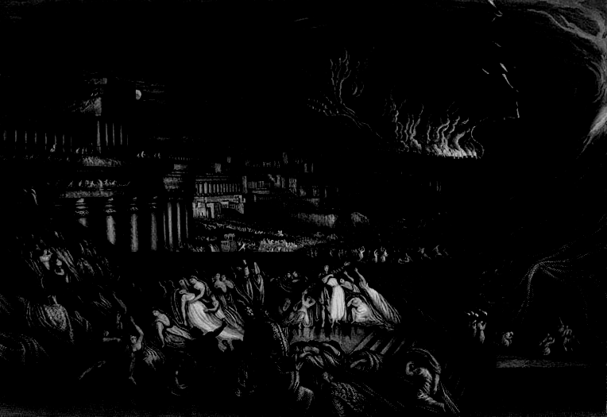
Two studies in Nahum

Introduction

Nahum is an oracle prophesying the doom of Ninevah, the capital city of the powerful and brutal Assyrian empire. In 722 BC, the Assyrians had conquered and demolished the northern kingdom Israel. In 701 BC they came up to the walls of Jerusalem but were turned back by God in the reign of Hezekiah,when everything seemed lost for the southern kingdom Judah. (See Isaiah 36-37 and 2 Kings 19). However Hezekiah’s son Manasseh and grandson Amon are remembered for their rebellion against God and the decline of the kingdom of Judah. (2 Kings 21, 2 Chr 33) It is most likely that Nahum was written in the latter days of Manasseh, around 650 to 642 BC, when he returned to worshipping God and restored this worship to Judah. (2 Chron 33:10-20)

At the time it was made this prophesy must have seemed like a pipe dream as the Assyrians were still at full strength (Nahum 1:12) and so much more powerful than the nations around them. However, it was fulfilled when Assyria was conquered by the Babylonian empire in 612 BC. The Babylonians would later conquer Judah as well.

Nahum 1 – A jealous and holy God

Read Nahum 1:1-15.
What stands out to you?

How does the book introduce itself?

Nahum means “comforter”. How might this vision have comforted the southern kingdom of Judah?

Focus on verses 2-8.
How does Nahum describe God's character? How does he describe God's power?

What does it mean for God to be “jealous”? (v2) What does it mean God dislikes?

How is God “slow to anger” (v3)?

What images does Nahum use to depict God? What do these images express about God's power over the world?

How does God relate to those who trust him? How does he relate to his enemies?

Why is God a refuge in your days of trouble?

What should this mean we should do when we have our lives are difficult? Do we do this?

How does this passage show God's justice?

What about God's justice comforts you? What makes you uncomfortable?

Focus on verses 9-15.
How does Nahum describe God's enemies?

What is God going to do to Nineveh? Why?

Why might Judah have found this announcement hard to believe?

In what way does God say that the way he treats Judah will change? (v12-13)

How is Judah commanded to respond?

What does God promise Judah in verse 15?

When does this end up happening?

How does the death of Jesus demonstrate the character and power of God?

How does Jesus “bring good news” and “publish peace” for God's people?

What kind of peace does Jesus offer?

How does God's bringing peace through Jesus' death affect our understanding of God’s justice?

Both God’s justice and the mercy he shows through offering peace in Christ are central to our Christian lives. How should these change how we relate to those around us today?

Suggested prayer points:

- Praise God that he is perfectly just yet patient with our sins, so that some may be saved
- Thank him for sending his son to shelter us from God's wrath against sin
- Ask that we would know more and more of the peace of God in our lives

Nahum 2 and 3 – The Judgment of God

Read Nahum 1:14 to 2:13.
What parts of the passage struck you?

Focus on 2:1-9.
How does the passage start? Why?

What does the passage describe?

What is Nahum communicating to Judah? How is this expressed?

Why is Nineveh falling? (1:14)

What is the connection between Nineveh's fall and the restoration of Jacob and Israel? (v2, 8-9)

Read Nahum 2:10 to 3:7.
How is Nineveh described in 2:10-12? Why?

What is God's response to this image?

How is Assyria's past described in 3:1-4?

How does God respond?

What pattern do we see in these two sections?

What do we think of God’s judgment?

Read Nahum 3:8-13.
How does God undermine Nineveh's pride?

Do you think your nation is invincible? How do you cope with violence and defeat?

Read Nahum 3:14-19
What images does God use to mock Assyria?

How do we feel about this picture of total destruction?

How does the book end? What does the ending emphasise?

Should we rejoice when the wicked perish?

Is God our strength in difficulty? In what ways do we struggle to trust him?

How does the offer of mercy that God makes in Jesus' death and resurrection change our view of God's judgement?

Does Jesus coming mean that God’s judgment will not occur? Why not?

What does the certainty of God’s judgment mean for all those who do evil today?

How should this change how we see and relate to others? For example: Do we need to seek revenge? You may want to read and consider Romans 12:17-21.

Suggested prayer points
- Thank God that he is not only a God of justice but one of mercy as we see in Jesus
- Ask God to deliver justice on behalf of the persecuted church around the world
- Pray that we would know the certainty of God’s mercy and judgment
- Pray that our knowledge of God’s mercy and judgment would be reflected in our lives

Studies prepared by Andrew Cooper and Lucas Sharley, 2016. Cover image by John Martin.

