Wait
for the
Lord
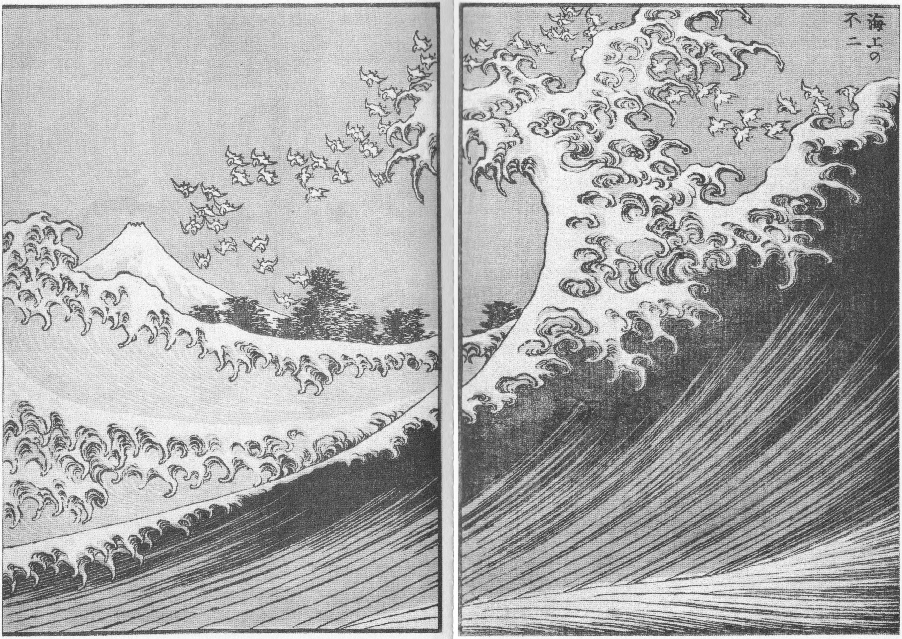

Three studies in Zephaniah

Introduction
Zephaniah prophesied when Josiah was king of Judah, the southern kingdom. King Josiah is described in glowing terms (see 2 Kings 22). The book of the law was discovered during Josiah’s reign and Josiah made sure that appropriate reforms were implemented so that the Israelites would follow it.

However, Josiah's kingship was the last ray of hope before the exile to Babylon; and even in his reign the hearts of the Israelites seem to have clung to idolatry. When Josiah died in battle, his son and grandsons did not follow God like he did and Judah went back to its previous ways. Judah came under Babylonian rule before Jerusalem was destroyed. (2 Kings 23-25)

Zephaniah is the only prophet with ancestors listed back three generations, which suggests that the Hezekiah referred to was the King of Judah and Josiah’s great grandfather.

But the book stands on its own merits. It does take much of its phrasing from Deuteronomy, suggesting that Zephaniah was written after the book of the law was rediscovered in 622 BC.

Zephaniah 1 – A full and sudden end
Read Zephaniah 1:1-18.
What impression does the passage make on you?

Focus on Zephaniah 1:1-6.
What does God say he will do? To whom?

What is your reaction to what God says here?

Zephaniah's prophecy is strongly connected to the various covenants (formal promises) God made to the Israelites. God sweeping away everything from the face of the earth including men, animals and birds (Zep. 1:1-3), reminds them of the flood and the promises given to Noah(See Gen 6:20, 9:11). A prepared sacrifice with invited guests (Zep. 1:7) is a theme that first occurs in Genesis 15, where God also promises Abraham a son and offspring as numerous as the stars. The descriptions of darkness and clouds on the Great day of the Lord (Zep. 1:15) alludes to the “black clouds and deep darkness” (Dt. 4:11) at Mount Sinai when the Law was given.

The Law ends with the promised curses (Dt. 28) for if the people are disobedient, but also the promise that He will be faithful when they seek Him again. (Dt. 30) The passages with their allusions here raise the terrifying expectation of judgment heir God. However, it also reminds them that God is faithful and that this judgment is reflection of him keeping his promises to His people. They should return to Him and wait for Him to keep his further promise to restore his blessings when his people return to Him.

How light do God’s promises cast on his judgment in Zephaniah?

Why is God angry with his people? (v4-6)

What does this show us about what God wants for his people?

Who are you trying to please in your day-to-day life? Do you have divided loyalties?

Focus on Zephaniah 1:7-13.
Why does God command silence?

Priests and followers of Dagon did not step on the threshold of their temples, because when the ark of the covenant was brought into Dagon’s temple the idol of Dagon twice fell before the ark. The second time they found his head and hands were broken off and lying on the threshold of the temple. (1 Samuel 5:1-5).

What do those who avoid stepping on the threshold represent?

The word for traders in verse 11 is also used to refer to Canaanites in general and as such is deliberately used.

Why shouldn’t there be foreign clothing and Canaanites in Israel? How do they affect Israel's relationship with God?

Sacrifices were part of covenant ceremonies.
What sacrifice is at the centre of our covenant with God? How does this change the way we read Zephaniah’s prophecy?

Who does Zephaniah single out for punishment? Why? (v8-9, 12-13)

How does God promise to punish them?

How would you describe being complacent? Why is it a problem?

In what ways can we be complacent as Christians? Do we ever not care what God thinks?

Focus on Zephaniah 1:14-18.
How is the great day of the LORD described?

Why does God bring judgement on mankind?

What sources of confidence turn out to be useless? (v14, 16, 18)

How does remembering the day of judgement change our perspective?

Are we ever tempted to place our confidence in material things? When?

Read 1 Peter 4:12-19.
Where does God's judgement begin? How does it continue?

How should Christians respond to suffering? (V13, 15, 19)

How does this compare to Zephaniah's declaration?

Does anything in your life need to change?

Prayer Points:
- Thank God that he is a just and merciful God who gives us the hope of sharing in Jesus’ glory.
- Ask God’s help in the areas where we are complacent
- Pray for the challenges this study has raised for us in our lives

Zephaniah 2 – Seek the Lord
Read Zephaniah 2:1-15.
What impression does this passage leave?

Focus on Zephaniah 2:1-3.
How does Zephaniah describe those he is speaking to? (v1, 3)

What are they told to do? (v1, 3) Why?

What attributes does God value here? (v3)

How would you describe righteousness and humility?

How can we seek them?

How do we feel about avoiding the Lord’s anger as motivation to seek him?

The Israelites are being called together to change their ways and avoid God’s anger. Are there things of which we need to repent, as a congregation? As individuals?

How does Jesus shelter us from God’s anger?

Do Christians still need to change our behaviour? Why or why not?

Focus on Zephaniah 2:4-15.
The cities listed in verse 4 are four of the five cities of the Philistines (the other being Gath - see 1 Sam. 6:17). How will the day of God's anger affect these cities?

What does Zephaniah say to the coastlands? How will the coastlands end up? (v5-9)

God’s promises are made to a “remnant” of God’s people implying that judgment would come on Judah first. But Zephaniah’s prophecy was in the time of Josiah, a king who turned to the Lord, “with all his heart and all his will and all his strength”(2 Kings 23:25) removing all idols and points of worship other than the temple.

Why would this judgment and call for repentance sound strange in the time of King Josiah? What does it suggest about God’s people?

What does this suggest about religious movements that rely on one leader? How is Jesus different?

What does Zephaniah promise the remnant of God's people? (v7, 9)

How does God deal with Moab and Ammon? Why? (v8-10)

Do we need to defend God’s people from insults and threats? How should we react?

The Cushites ruled Egypt, and were a powerful nation of whom Israel lived in fear. Why might they be included so casually? (v12) What does this suggest about how God saw them?

How is Nineveh described before God acts? (v15)

What does God promise to do about Nineveh? (v13 to 15)

How will the people suffering God's judgment ultimately relate to him? (v11) When does it say this will happen?

While we might not literally worship images of gods, how might worshipping other gods or idols apply to us today?

Are there things on which you feel that you must spend time or money? Do they exert an unhealthy control over the rest of your life?

Read Revelation 20:11 to 21:4.
How does Jesus shelter us on the day of judgement?

In Zephaniah 2 we saw a promise of restoration and land for God's people. How do Zephaniah’s promises come true in Revelation 21?

How do these promises of God encourage us to seek God now?

Prayer Points:

- Thank God that he is in control of our lives and gives us the hope of going to be with Christ
- Ask for the areas where there are things that exert unhealthy control in our lives that God would enable us to change
- Pray that the hope of being with Christ would shape how we live

Zephaniah 3 – Purifying the people
Read Zephaniah 3:1-20.
How does the passage strike you?

What city is being addressed? What is wrong with Jerusalem?

How is God described? How is that comforting?

What has God already done? (v6) What was the response from this city to God’s correction? (v7)

God promises his discipline today to those that he loves (see Hebrews 12:5-8) How do we, as God’s people today, respond to God's discipline?

What is God going to do? What does this show about him?

What does it mean for God's anger to be jealous? (v8)

What is the result of God's jealous anger?

What does God promise to his people?

Who will be in Jerusalem? (v9, v10, v12) Why?

Why are God's people secure? (v12-13) What are the results of this?

What makes us insecure? How does this passage help us deal with our insecurities?

Read Zephaniah 3:14-20.
What should God's people do? Why?

How does God relate to his people?

Read Ephesians 2:13-18.
What has Jesus done for us?

What hostility has he destroyed?

How does this achieve what Zephaniah promised to Israel's remnant?

Why does accepting Jesus' death help destroy our pride?

Does this make us rejoice and give us courage?

Prayer Points:
- Thank God that we are secure because we are his people who he loves and has reconciled us with him
- Pray for the areas where we feel insecure that we will trust God with them
- Pray that we will rely more and more on God and what he has done for us on the cross rather than ourselves and that would give us courage but also humble us.

Studies prepared by Andrew Cooper and Lucas Sharley, 2016. Front cover image by Hokusai.

